Video Converter App User Manual
1. Welcome 2
2. Add Video Files 3
2.1 Camera Roll 3
2.2 iTunes File Sharing 4
2.3 Wi-Fi Upload 5
2.4 Dropbox 7
2.5 Microsoft SkyDrive 7
3. Convert Video Files 8
4. Share Converted Video 10
4.1 Play Converted Video 10
4.2 Copy Converted Video to Photo Library 11
4.3 Wi-Fi Transfer Converted Video 11
4.4 Open Converted Video in Other Apps 13
4.5 Refresh Converted Video 13
4.6 Delete Converted Video 13
5. Settings 13
6. Availability 14

1. Welcome
With Video Converter App, you will be able to transfer your favorite local video files onto iOS devices and convert them into iTunes-, iPad-, iPhone-, iPod-compatible videos to watch them on the go. It also lets you import video files from Dropbox, SkyDrive and Camera Roll to convert and play.
Video Converter App supports a host of video formats, including AVI, WMV, MOV, MP4, 3GP, M4V, QT, RM, RMVB, FLV, MKV, MTS, M2TS, etc. It is also useful when you want to import your video files into popular video editor apps like iMovie and Pinnacle Studio.
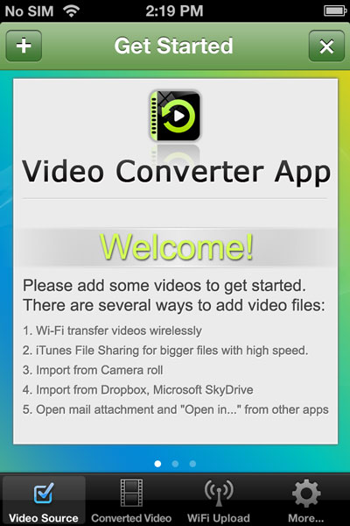

2. Add Video Files

2.1 Camera Roll
Run Video Converter App, tap the + button on the top left and choose to Import Videos from Camera Roll.
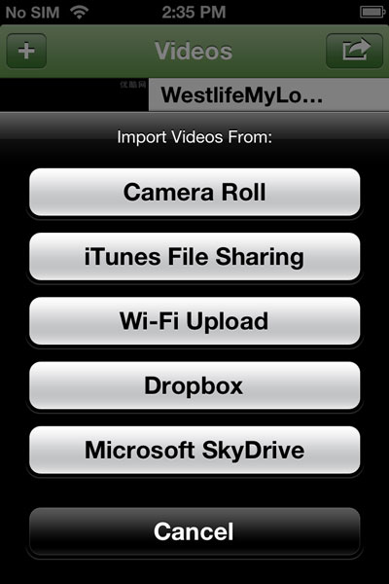
Note: Video Converter App requires access to your photos in order to read video from photo library. You need to go to Settings -> Privacy > Photos and turn on Converter.
All video clips in your Camera Roll, Photo Library or Photo Albums will be listed. You can choose and add any of them to the conversion queue.

2.2 iTunes File Sharing
You can also transfer video files to Video Converter App via iTunes File Sharing.
- Connect your iPhone, iPad or iPod to computer with USB cable.
- Select your iOS device from iTunes.
- Click the Apps tab and scroll down.
- Under the File Sharing section, select "VideoConverterApp".
- Drag and drop video files from your computer or click the Add... button to add local video files to the app.
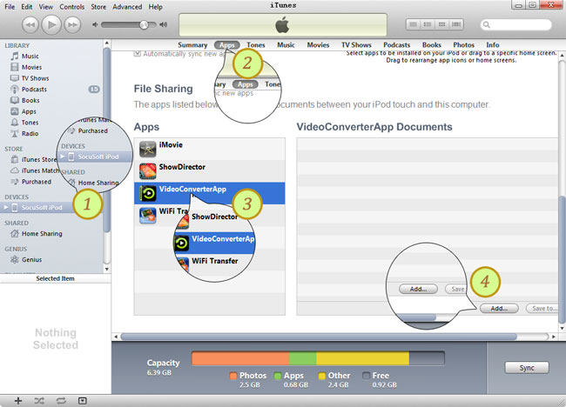

2.3 Wi-Fi Upload
Run Video Converter App and switch to the WiFi Upload tab.
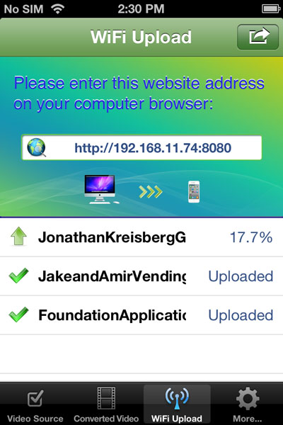
Open a web browser on your computer.
Type the URL address as shown in the Wi-Fi Upload screen into the address bar.
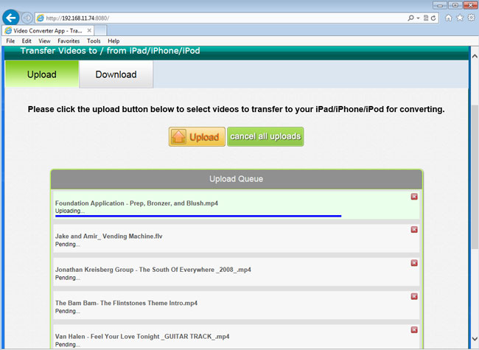
There will be an Upload button in interface of the browser.
Choose and upload your local video files to your device for conversion and playback.

2.4 Dropbox
Run Video Converter App, tap the + button on the top left and choose to Import Videos from Dropbox
It requires that you connect Video Converter App with your Dropbox. You will need to log in to your Dropbox account and let Video Converter App have access to your Dropbox files.
Then you can choose and add any of the video files in your Dropbox to the conversion queue.

2.5 Microsoft SkyDrive
Run Video Converter App, tap the + button on the top left and choose to Import Videos from Microsoft SkyDrive.
It requires that you connect Video Converter App with your SkyDrive. You will need to log in to your Microsoft SkyDrive account and let Video Converter App have access to your SkyDrive files.
Then you can choose and add any of the video files in your SkyDrive to the conversion queue.

3. Convert Video Files
When the video files are added to Video Converter App via WiFi Upoad or iTunes File Sharing, imported from Camera Roll, or downloaded from Dropbox or Microsft SkyDrive, they will go to the Video Source tab.
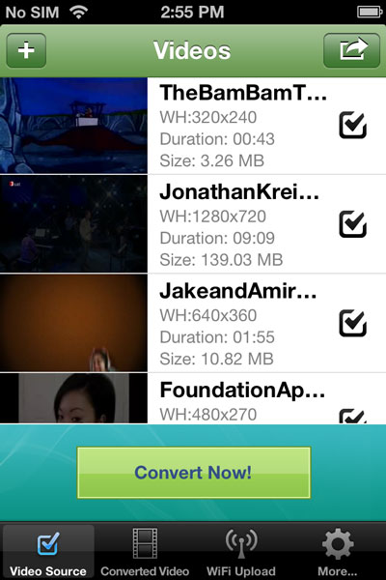
Press the Convert Now! button to start converting video files into iTunes-, iPhone-, iPad-, iPod-compatible video.
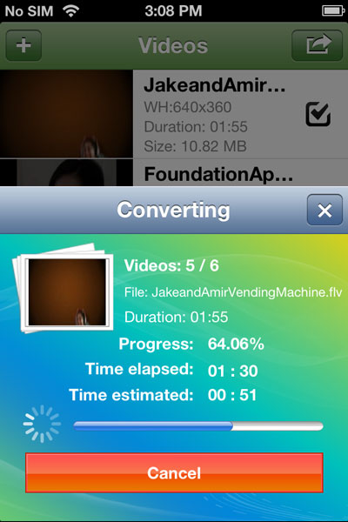
The converted video files will be added to the Converted Video tab.
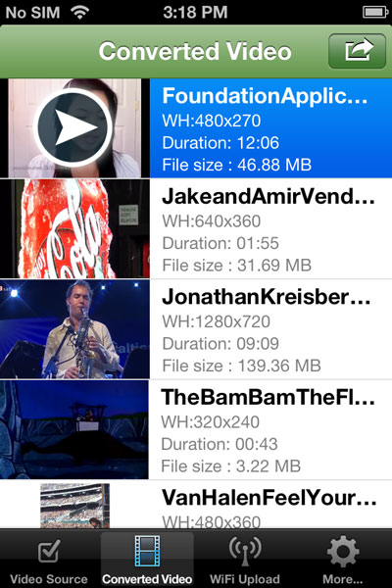

4. Share Converted Video

4.1 Play Converted Video
To play the converted video files on your device, just press the button and tap Play.
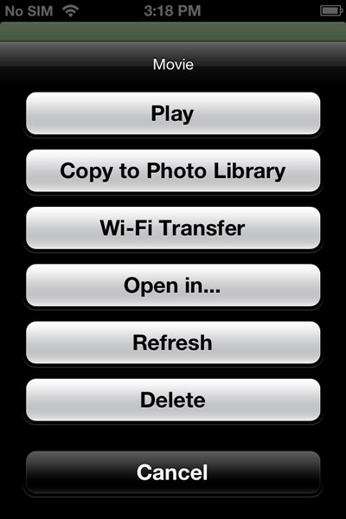

4.2 Copy Converted Video to Photo Library
To copy the converted video files to the Photo Library, just press the button and tap Copy to Photo Library. While the video files are saved to the Photo Library, you will be able to import them into popular iOS video editing apps such as iMovie.

4.3 Wi-Fi Transfer Converted Video
You can also transfer the converted video back to your computer via Wi-Fi. Press the button and tap Wi-Fi Transfer.
Then there will be a pop-up message asking you to enter the HTTP address into your web browser to download videos to your computer.
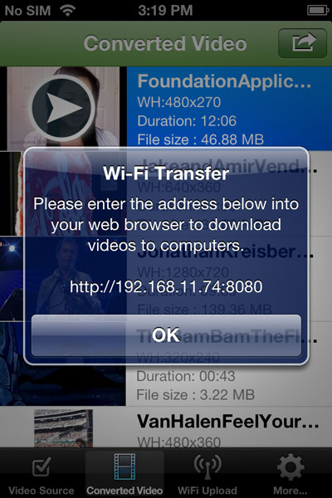
Open a web browser in your computer and type the address as shown in the message. Switch to the Download tab to download the converted video files to your computer.
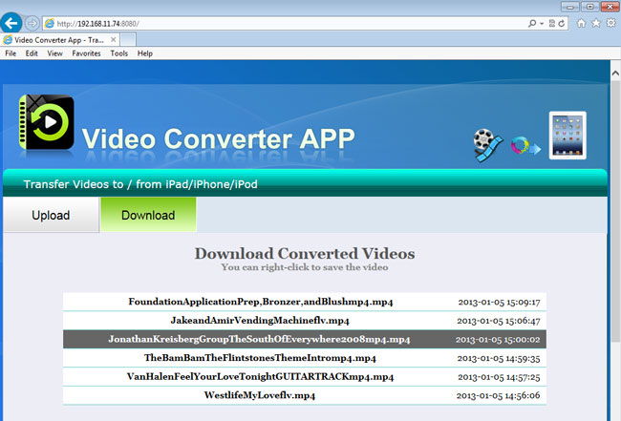
Note: You need to make sure that your iPhone/iPad/iPod touch and your computer are connected to the same network in order to transfer converted video files to your computer via Wi-Fi.

4.4 Open Converted Video in Other Apps
To open converted video in other apps, just press the button and tap Open in...

4.5 Refresh Converted Video
Press the button and tap Refresh to update the converted video files.

4.6 Delete Converted Video
Choose any of the converted video files, press the button, and tap Delete to remove it.

5. Settings
You can choose to keep original video files, copy converted video files to photo library and select the video quality and video size you need.
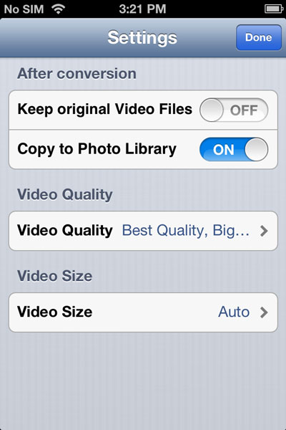

6. Availability
Video Converter App is only $1.99 USD (or equivalent amount in other currencies) and available worldwide exclusively through the App Store in the Entertainment category.
Video Converter App is compatible with iOS 5.0 or above and works with iPhone 5, iPhone 4S, iPhone 4, iPhone 3GS, iPad 4, The New iPad, iPad 2, iPad 1, iPad mini, iPod touch 5 and iPod touch 4.

https://itunes.apple.com/us/app/video-converter-app/id549355396

